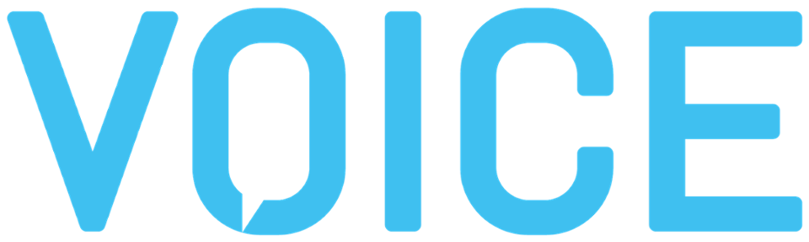
October 5-8, 2020 | Washington D.C.| www.voicesummit.ai
January 28th, 2020
Name:
Company:
Role:
Address:
Phone:
Email:
Passport Number:
Date of Issue:
Date of Expiry:
Date of Birth:
Dear [Attendee Name],
On behalf of ModevNetwork LLC, we are pleased to invite you to attend VOICE Summit taking place on October 5 - 8, 2020. The event will be hosted at the Hyatt Regency Crystal City in Arlington, Washington D.C.
VOICE Summit is the world’s largest voice technology conference and a global stage for over 5,000 developers, conversational designers, startups, brands, agencies and executives at the forefront of the voice-first era.
Organized by Modev, VOICE Summit will feature dozens of keynotes, panels, workshops and an EXPO showcasing hundreds of pioneering companies from around the world. It’s an inclusive conference designed for everyone from every industry—including healthcare, FinTech, enterprise, transportation, gaming, entertainment, smart home, smart cities, retail, and hospitality.
VOICE Summit will begin on Monday, October 5th and end on Thursday, October 8th—a full four days of learning, networking, and business opportunities. We hope to see you there and welcome you into our fast-growing VOICE Community.
For the latest information about the conference and tips for accommodation during your visit, please visit voicesummit.ai
Sincerely,
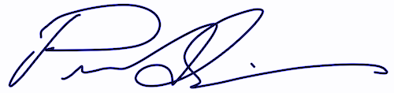
Peter Erickson
CEO, Modev
Organizer, VOICE Summit
pete@modev.com
703-473-2148

