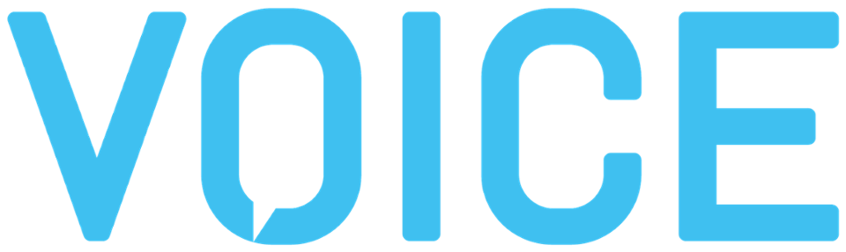
October 5-8, 2020 | Washington D.C. | www.voicesummit.ai
Date

<Supervisor’s name>,

I would like to request approval to attend VOICE Summit on October 5-8, 2020, at the Hyatt Regency Crystal City in Arlington, Washington D.C.

VOICE Summit is the world’s largest voice-tech conference attracting 5,000+ developers, conversational designers, startups, brands, agencies and executives at the forefront of the voice-first era. Organized by Modev, this four-day conference will feature keynotes, panels, workshops and an EXPO showcasing hundreds of pioneering companies from around the world.

This conference is an exceptional opportunity to learn the latest trends in our industry, discover how leading companies are handling similar challenges, and network with potential clients, partners, and investors.

By attending this conference, I will have:

- Access to over 200 educational sessions from industries including Healthcare, FinTech, Enterprise, Transportation, Gaming, Entertainment, Smart Home, Smart Cities, Retail, and Hospitality.
- The opportunity to learn first-hand about what’s next in voice technology, which technologies to adopt, and how we can enhance our business strategy for 2020.
- Multiple, high-level networking opportunities to promote our company’s profile, as well as develop valuable relationships and contacts.
- The chance to push us one step ahead with early access to the latest information and product demos.

Costs
The approximate investment for my attendance is as follows: (complete information as appropriate)

Travel Costs $
Accommodation (4 nights at $139-$179/night*) $556 - $716
Meals (5 days at $61/day**) $305
Main Stage + EXPO + Breakouts Pass $
Total Cost to Attend $

*The conference has specially negotiated hotel rates for attendees ranging from $139-$179/night at local hotels.
**$61/day is the prevailing government rate for meals and incidentals.

VOICE Summit presents multiple opportunities for me to improve, develop, and expand my network to the company’s benefit. Upon my return, I plan to submit a summary of my learnings and how we can incorporate them into our business strategy moving forward.

Thank you for your consideration.

Sincerely,

Your Name

